New Affordable Care Act (ACA) Medical Insurance Rules for S Corporation Shareholders and Employees
Owners and employees of small businesses (specifically, those who own more than 2% of the stock in an S Corporation) face new rules to follow under the Affordable Care Act (ACA) regarding the reporting requirements and taxability of health insurance and other benefits.
In the past, health insurance paid on behalf of more than 2% shareholders was deducted by the corporation. The amount was reported in Box 1 of the corporation’s W-2, deducted on the shareholder’s 1040, and not subject to payroll taxes. Starting in 2014, the IRS only allows this treatment if the company maintains a group plan or a one-employee/owner plan. If you currently maintain a group plan or the owner/employee is the sole participant in the plan, the new rules DO NOT affect you.
Now under the ACA, health insurance paid by the entity or by the individual employees may need to be reported differently than in prior years. Depending on the situation, there are three main scenarios that need to be considered: 1) If the entity has a one-employee insurance plan, 2) If the entity has a group plan, 3) If the entity has a non-group plan where the employer reimburses the employee for insurance premiums maintained by the business.
It is important to consider the third situation where the employer reimburses the employee or shareholder for health insurance premiums paid in a non-group plan. Beginning in 2014, the new law requires these health insurance payments to be included in wages on the individual’s W-2, subject to Social Security and Medicare taxes in Boxes 3 and 5. Previously, these payments only needed to be reported in Box 1 and were not subject to payroll taxes. Your 4th Quarter payroll deposit may need to be adjusted to include the additional payroll tax on the health insurance benefits paid by the employer.
In the first two situations where an entity has a one-employee/owner plan or when a group insurance plan is in place, the health insurance paid is not subject to Social Security or Medicare taxes, and will only need to be included in Box 1 of the W-2, NOT to be included in Boxes 3 and 5 (as has been the case in prior years).
Correct reporting and treatment of health insurance paid is crucial, as incorrect reporting could expose your entity to a $100-per-day-per-individual ACA market reform noncompliance penalty. The following chart will help you determine the taxability of your health insurance on the W-2:
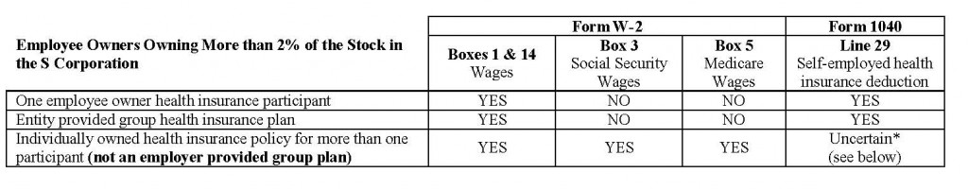
* In any case, health insurance paid should be reported in Box 14 of the shareholder’s W-2 to allow potential deduction on the front page of the 1040. Reporting and deductibility of SE Health Insurance on the owner/employee’s individual return is still uncertain as the IRS and Department of Labor (DOL) conflict on the issue.
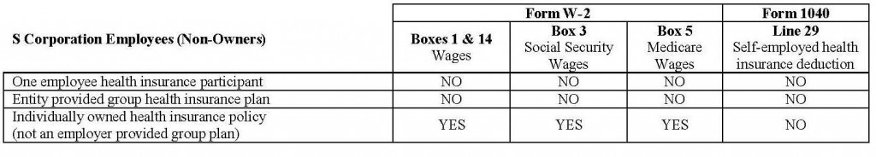

Additionally, under the new ACA rules, an entity is not allowed to provide a Section 125 Flexible Spending Account (FSA) unless it has a group health insurance plan. Health Reimbursement Arrangements (HRAs) which reimburse non-group health insurance are also no longer available tax-free under the HRA; however, certain ancillary benefits (such as vision, dental, and long-term care) and Health Savings Accounts (HSAs) payments could still be available.
If Kalambo Consulting provides W-2 processing for your entity, we will need your health insurance information at the very least by the end of the year in order to calculate and timely deposit the correct Social Security and Medicare taxes on any additional health insurance wages, which will be included in your 941. We will need the amount of health insurance paid for each owner and employee and what type of plan you have (single-member, group, or non-group).
As you may be aware, there are some provisions in the tax code that may yet need to be amended. We will continue to follow developments closely and update our clients as we receive information. In the meantime if you have any questions please contact us at chilobe@kalambocpa.com or info@kalambocpa.com.

